From Intelligence Center to Genius Hub: Your Complete Upgrade Journey
By Urvashee Gupta
Db2 Intelligence Center provides core capabilities for database monitoring and query execution. However, modern database administration increasingly requires systems that support proactive analysis and issue prediction, rather than relying solely on reactive operational tools.
IBM Db2 Genius Hub is an updated platform designed to address these requirements. The upgrade process includes automated migration of the existing environment, preserving key components of current deployments, including:
• Repository database and associated historical data
• Target database configurations
• Connection definitions and job configurations
This approach ensures continuity of existing configurations while enabling access to updated user interfaces, enhanced monitoring capabilities, and integrated analytical features.
The following sections outline the prerequisites, upgrade procedure, and validation steps required for a successful transition.
What Makes Genius Hub Different?
Genius Hub isn't just an update—it's a transformation in how you interact with your databases:
Capability | Main reason to move | What you gain (example)
AI-powered intelligence | Act before performance issues hit users | Query/index recommendations, predictive capacity insights
Modern user experience | Finish common tasks faster | Streamlined navigation, better search/filtering, customizable dashboards
Advanced monitoring | See health across instances in one place | Richer metrics & visuals, optional log analysis via Remote OS Service
Future-ready platform | Keep pace with new capabilities | Continuous updates, cloud-ready architecture, extensible APIs

Prerequisites: Before You Begin

1. System Requirements
- Running any version of IBM Db2 Intelligence Center.
- OS: Linux (RHEL, SLES, or Ubuntu).
- Storage: Minimum 2GB free disk space for Genius Hub.
- Network: Verified connectivity to all database instances.

2. Database Prerequisites
- DBs: At least one target database configured (e.g., ICtargetdb).
- Repository Database: Configured and accessible (e.g., ICrepodb with IBMCONSOLE schema)
- Permissions: DBADM, CREATETAB, BINDADD, CONNECT, IMPLICITSCHEMA, and LOAD granted to the upgrade user.
- Repository Database Version Check: Check the type and version of your repository database Currently, upgrading is supported for Db2 version 11.5 and later
- If your repository database version is earlier than Db2 version 11.5, upgrade your database first before proceeding
- Repository Database Disk Space: When you upgrade to IBM Db2 Genius Hub, new tables are created and data in the repository database is upgraded
- Check the disk space of your repository database and ensure it has enough free disk space to complete all processes
- Recommended: At least 20-30% free space in the repository database tablespace

3. Intelligence Center Prerequisites
- Confirm the Status of IBM Db2 Intelligence Center: IBM Db2 Intelligence Center is not required to be stopped before you begin the upgrading process. However, It is recommended Stop DIC before upgrade to avoid any conflicts or data inconsistencies.

4. Critical Pre-Upgrade Steps
Backup your repository database
db2 backup database ICrepodb to /backup/location

Download Genius Hub
  - Navigate to IBM Tech Central (https://techzone.ibm.com)
  - Search for "IBM Db2 Genius Hub"
  - Select the latest version
  - Choose Linux as your platform
  - Download the .tar file to your local machine
  - Transfer the file to your Linux server

Pre-Upgrade Checklist
Before proceeding, verify:
- Repository database backup completed successfully
- Current DIC configuration documented (port, connections, etc.)
- Database connection credentials available
- Genius Hub installation file transferred to Linux server
- Sufficient disk space available (check with df -h)
- No critical jobs running in Intelligence Center

The Upgrade Process: Step-by-Step
Moving on now to the actual upgrade.

Step 1: Extract the Genius Hub Package on the Linux Server
$ tar -xzvf ibm-db2GeniusHub-1.1.0.0-linux.tgz
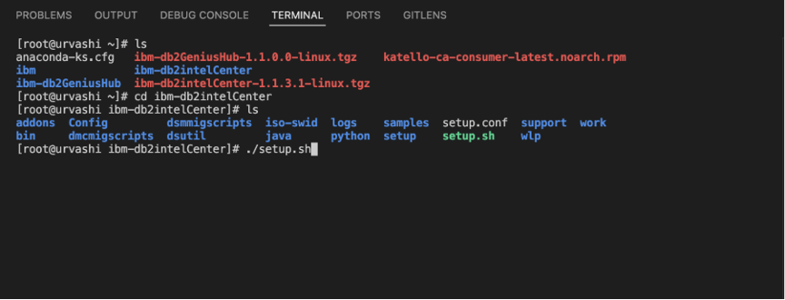

Step 2: Initiate the Upgrade
Make setup script executable (if needed)
chmod +x setup.sh
Run the setup script
./setup.sh
The installer will present you with three options:
Welcome to IBM Db2 Genius Hub Setup
# Please select an installation option:
1. Perform a new installation of Genius Hub
2. Upgrade existing IBM Db2 Intelligence Center to Genius Hub
3. Upgrade existing DB2 Management Console to Genius Hub
Please select an installation option:
Enter your choice [1-3]:
Select option 2 to upgrade from Intelligence Center.
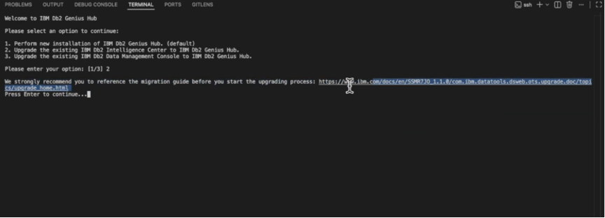

Step 3: Provide Intelligence Center Installation Path
The installer will prompt you for your existing Intelligence Center installation directory:
Provide the full path to your DIC installation, for example:
/home/user/ibm-db2IntelligenceCenter
Important: The installer will validate this path and detect your existing DIC installation.

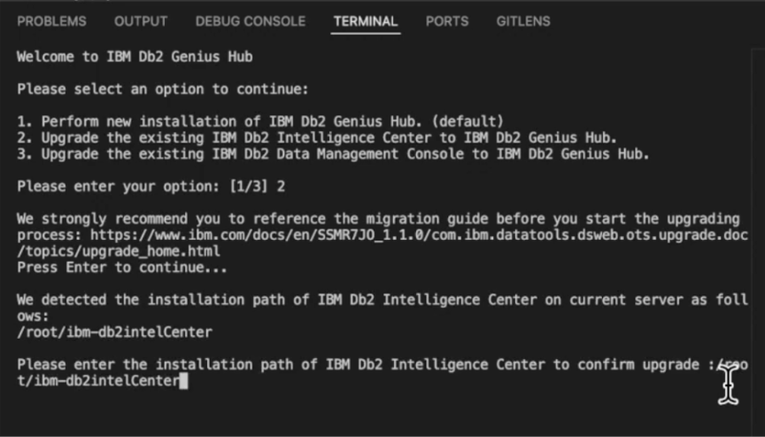

Step 4: Stop Intelligence Center Service
The installer will detect if Intelligence Center is currently running:
IBM DB2 Intelligence Center is currently running in the background.
It needs to be stopped before proceeding with the upgrade.
Do you want to stop IBM DB2 Intelligence Center now? [yes/no]:
Type yes and press Enter.
Alternative: If you prefer to stop DIC manually before running setup:
cd /path/to/intelligence-center
./bin/stop.sh
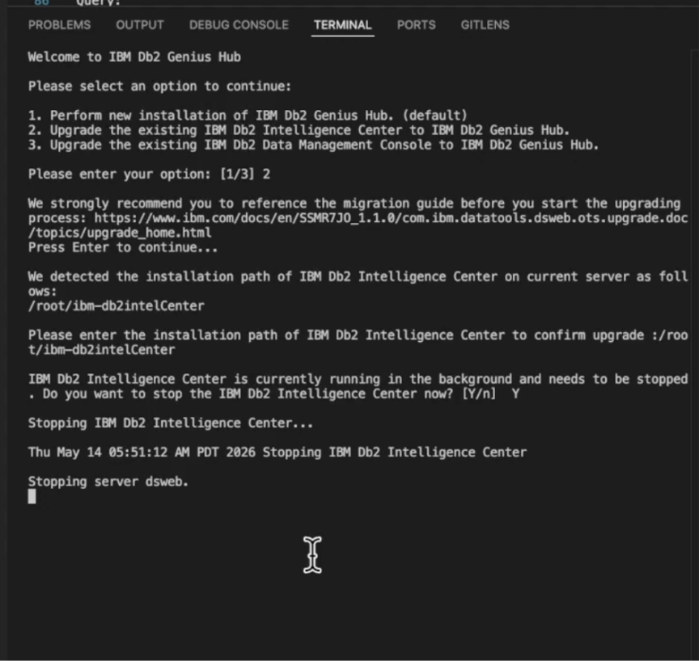

Step 5: Database Backup Reminder
The installer will remind you about database backups: Ensure you have backed up your repository database before proceeding.
If you completed the backup in the prerequisites section, type yes and continue.

Step 6: Repository Migration
This is the migration. The installer will automatically migrate your repository data:
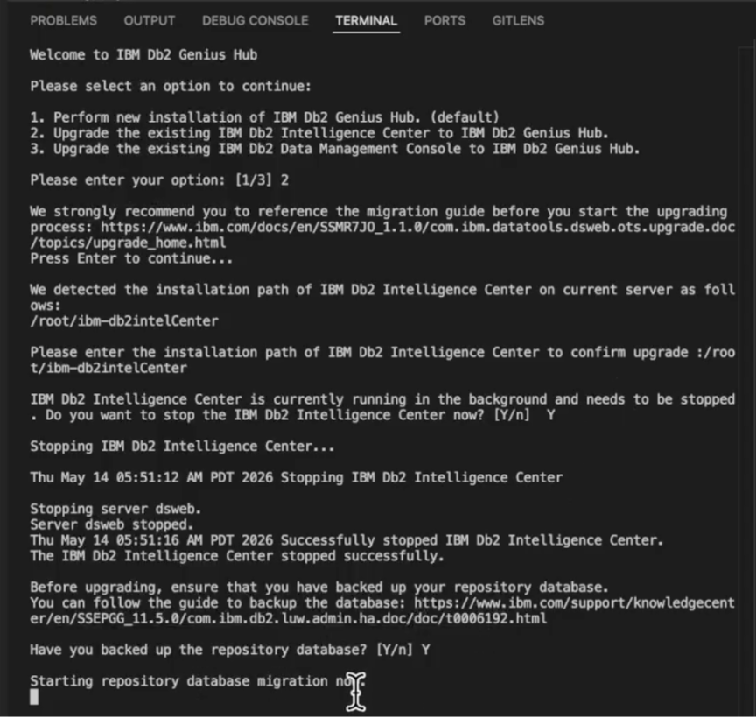
What's happening behind the scenes:
- Repository database schema is updated to Genius Hub format
- All database connections are preserved
- Target database configurations are migrated
- Job definitions and history are transferred
- User settings and preferences are retained
- Alert configurations are migrated
- This process typically takes 1-2 minutes depending on the size of your repository.

Step 7: Accept License Agreement
After migration, you'll be presented with the IBM license agreement.
Review the license terms and type 1 to accept.

Step 8: Review Configuration Settings
The installer will display the configuration settings from your setup.config file:
Welcome to IBM DB2 Genius Hub
The following settings are defined in the setup.config file:
Server Settings:
- Port: The web console port (default 11100, can be customized)
- Default User ID: Your Linux username
- Repository Database: Should match your existing DIC configuration
- Repository Host: your repo db host
- Repository Port: it’s port
Do you want to continue setting up the product with this configuration? [yes/no]:
If everything looks correct, type yes to continue.
If you need to change settings, type no and edit the setup.config file before re-running setup.

Step 9: Complete Installation
The installer will finalize the setup:
- Moving new product files in place...
- Configuring Genius Hub services...
- Updating repository schema...
- Registering database connections...
- Installation completed successfully!
- IBM DB2 Genius Hub is now ready to use
Web Console URL: http://your-hostname:11100/console/
Login ID: urvashee
Password: [Use your Intelligence Center password]
Press Enter to exit...
Save these details! You'll need them to access Genius Hub.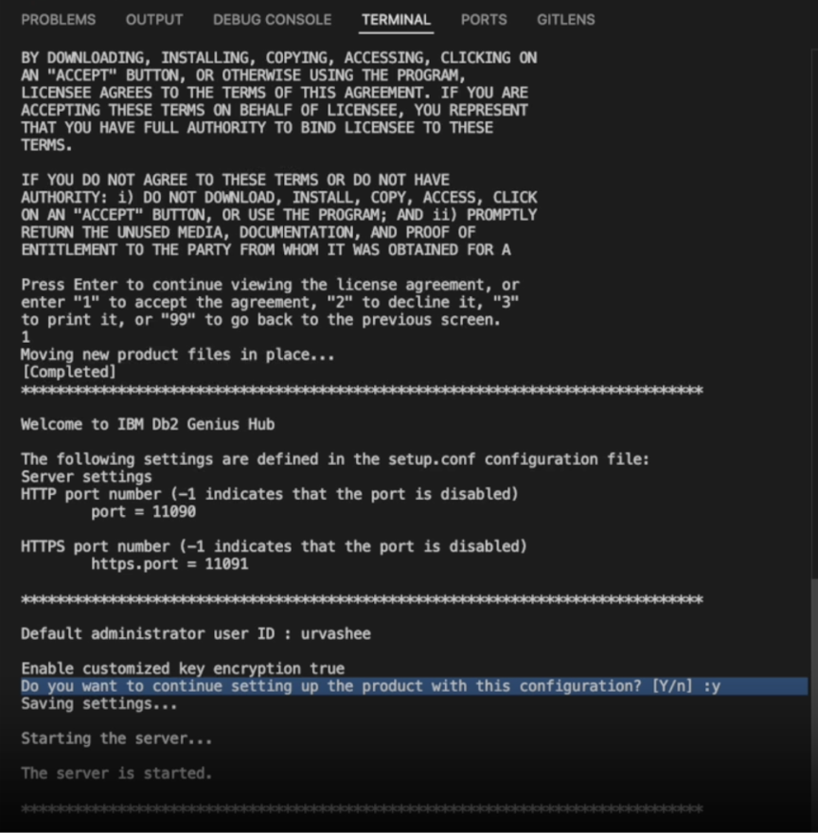

Post-Upgrade Verification
The upgrade is complete, but let's verify everything migrated correctly.

Access the Genius Hub Console
Open your web browser and navigate to the URL provided during installation:
http://your-hostname:11100/console/
Login Credentials:
- Username: The user ID shown during installation (typically your Linux username)
- Password: Use the same password you used for Intelligence Center

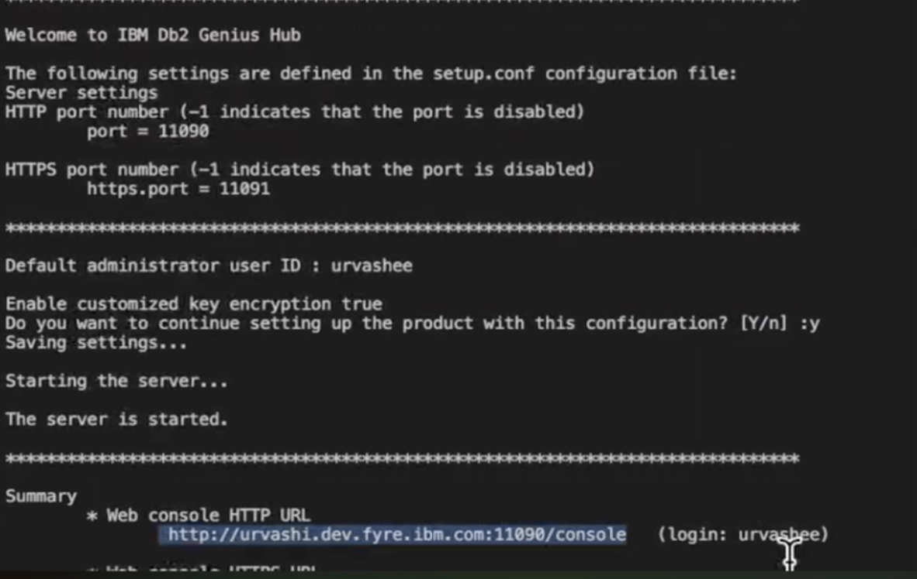

Verify Migrated Databases
Navigate to the Home page to see your database connections:
1. Check Repository Connection:
- Look for your repository database (e.g., ICrepodb)
- connection status shows as "Connected"
- Check that the schema is IBMCONSOLE
2. Check Target Databases:
- Verify all your target databases appear in the list and show connected
- Confirm database names match your DIC configuration
- Click on each database to confirm host, port, and schema information is correct
- Check that database statistics are being collected
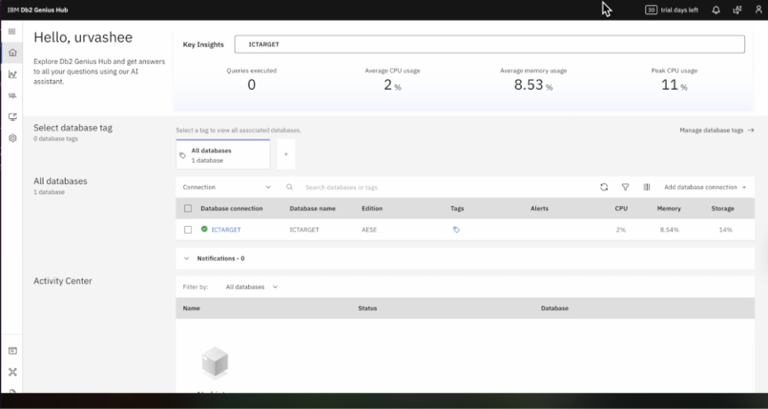

Test Database Operations
Let's ensure everything works as expected:
Test 1: Run a Simple Query
- Navigate to the SQL tab
- Select your target database from the dropdown
- Run a test query:
Test 2: Verify Monitoring
- Navigate to the database Overview page
- Check that performance metrics are being collected
- Verify monitoring graphs display data
- Confirm alert thresholds are configured (if you had them in DIC)
Test 3: Check Job History (if you had scheduled jobs in Intelligence Center)
- Navigate to Jobs section and verify job definitions are present
- Check job execution history
- Confirm job schedules are intact

Troubleshooting Common Issues

Issue 1: Login Credentials Don't Work
Symptom: "Invalid username or password" error
Solutions:
1. Verify Username: Use the exact username shown during installation
2. Check Password: Use your Intelligence Center password (not your Linux password)
3. Case Sensitivity: Ensure correct case for username
4. Reset Password: If needed, refer to Genius Hub documentation for password reset procedure
# Check configured username
cd /path/to/ibm-db2GeniusHub
cat setup.config | grep USER

Issue 2: Missing Databases After Upgrade
Symptom: Some databases from DIC don't appear in Genius Hub
Solutions:
1. Check Migration Logs:
cd /path/to/ibm-db2GeniusHub
cat logs/migration.log | grep -i error
2. Manually Add Missing Connections:
- Navigate to Home → Add database connection
- Enter connection details manually
- Test and save
3. Verify Repository Database:
-- Connect to repository
db2 connect to ICrepodb
-- Check for connection records
SELECT * FROM IBMCONSOLE.DATABASE_CONNECTIONS;

Video Walkthrough: See It in Action
Please refer to this 8-minute walkthrough of the process to upgrade to Db2 Genius Hub


Conclusion: Your Journey to Intelligent Database Management
Upgrading from Db2 Intelligence Center to Genius Hub represents more than a software update—it's a strategic move toward intelligent, AI-powered database management.
What You've Accomplished:
- Seamlessly migrated your repository and target databases
- Preserved all configurations, connections, and historical data
- Gained access to AI-powered insights and recommendations
- Positioned your organization for future database management innovations
The future of database management is intelligent, proactive, and powered by AI. With Genius Hub, that future is now.

Get Started
Db2 Genius Hub is available today with the new Db2 AI Standard and Db2 AI Advanced editions.
- Explore a free trial
- Schedule an executive briefing

Join the Db2 Community
Stay connected and continue learning:
- IBM TechXchange – Db2 LUW webinars and technical sessions
- IDUG – The global Db2 user community
- Db2 Documentation – Technical deep dives and best practices

About the Author
Urvashee Gupta is a Software Developer at IBM with approximately 7 years of experience in software development before this she worked with call logics. Before joining the Db2 team, she worked with vector databases. Currently, Urvashee is part of the Client Adoption Engineering (CAE) team, where she works on the Genius Hub product, helping customers successfully adopt and leverage its AI-powered capabilities.
Connect with Urvashee on [LinkedIn](https://www.linkedin.com/in/urvashee-gupta) or through the IBM Community.
Disclaimer
IBM Db2 Genius Hub is generally available as of March 5, 2026. Features and capabilities are subject to the terms of your license agreement. The upgrade process described in this article is based on Genius Hub version 1.1.0.0 and may vary slightly in future releases. Always refer to the official IBM documentation for the most current information. Back up your databases before performing any upgrade or migration operation.

